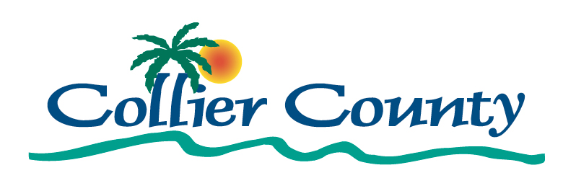
2020 Annual Action Plan

Collier County
Community and Human Services Division
3339 East Tamiami Trail
Health and Public Services Building H, Room 211
Naples, Florida 34112

Table of Contents
Executive Summary 3
AP-05 Executive Summary - 24 CFR 91.200(c), 91.220(b) 3
PR-05 Lead & Responsible Agencies – 91.200(b) 6
AP-10 Consultation – 91.100, 91.200(b), 91.215(l) 7
AP-12 Participation – 91.105, 91.200(c) 17
Expected Resources 21
AP-15 Expected Resources – 91.220(c)(1,2) 21
Annual Goals and Objectives 25
AP-20 Annual Goals and Objectives 25
AP-35 Projects – 91.220(d) 28
AP-38 Project Summary 30
AP-50 Geographic Distribution – 91.220(f) 37
Affordable Housing 39
AP-55 Affordable Housing – 91.220(g) 39
AP-60 Public Housing – 91.220(h) 41
AP-65 Homeless and Other Special Needs Activities – 91.220(i) 44
AP-75 Barriers to affordable housing – 91.220(j) 46
AP-85 Other Actions – 91.220(k) 48
Program Specific Requirements 51
AP-90 Program Specific Requirements – 91.220(l)(1,2,4) 51
Attachments 55
AD-25 Citizen Participation Attachments & Appendices 55

Executive Summary

AP-05 Executive Summary - 24 CFR 91.200(c), 91.220(b)
1. Introduction
Collier County is an entitlement jurisdiction eligible to receive community planning and development funding from the U.S. Department of Housing and Urban Development (HUD). As such, HUD requires that the County develop a Five-Year Consolidated Plan to identify its housing and community development priorities and outline a strategy to implement HUD programs. HUD also requires that the County prepare an Annual Action Plan showing the objectives the County plans to achieve each year. Collier County prepared its 2016-2020 Five-Year Consolidated Plan in 2016. This FY 2020-2021 Action Plan outlines goals, objectives, and projects for the fifth program year covered by the current Consolidated Plan. It also serves as the County’s application to HUD, requesting its allocation of Community Development Block Grant (CDBG), HOME Investment Partnerships (HOME), and Emergency Solutions Grant (ESG) funds.
HUD released Collier County’s FY 2020 allocations, showing that the County will receive $2,736,898 in CDBG funds; $731,113 in HOME funds; and $205,067 in ESG funds.
The goal of the community planning and development programs covered by this Annual Action Plan is to develop viable communities by providing decent housing, a suitable living environment, and expanding economic opportunities principally for people with low- and moderate-incomes. The County made funding determinations for specific projects during FY 2020-2021 based on input from residents, non-profit and social service agencies that serve low- and moderate-income residents, municipalities including the City of Naples, and other stakeholders. Input was collected during the planning processes for the 2020-2021 Action Plan and the 2016-2020 Consolidated Plan.
2. Summarize the objectives and outcomes identified in the Plan
Goals, projects, and objectives outlined in this 2020-2021 Action Plan are based on the goals developed during the planning process for the 2016-2020 Consolidated Plan, and recently as a result of community needs related to the coronavirus pandemic. Specific projects and objectives anticipated for the upcoming program year include:
- Public infrastructure improvements including crosswalk improvements on Goodlette Road in the River Park neighborhood and Peters Avenue sidewalk improvements in East Naples .
- Facility improvements including the construction of the Esperanza Place Community Center project and construction of a new fire station in Immokalee. The Community Center will serve as a safe, structured environment for individuals of all ages, abilities and backgrounds to learn, play and engage with the community around them.
- Public services to provide legal services to 150 victims of domestic violence, housing counseling for 180 LMI persons, tutoring and mentoring for 160 at-risk children and youth, and transportation for 20 persons with disabilities.
- Construction, acquisition, and rehabilitation of affordable housing and tenant based rental assistance (TBRA) for low- and moderate-income households for a total of 60 households.
- Shelter operations support to provide emergency and transitional housing for victims of domestic abuse.
- Rapid rehousing for 18 households.
- Homeless Management Information System (HMIS) support.
- Expansion of rental and mortgage assistance activities, creation of small business assistance and economic development opportunities to assist individuals, households, and businesses impacted by COVID-19 and health care assistance including PPEs, testing and other needs of health care providers.
- Administration of CDBG, HOME, and ESG programs by Collier County Community and Human Services Division.
3. Evaluation of past performance
Each year, Collier County reports its progress in meeting its five-year and annual goals by preparing a Consolidated Annual Performance Evaluation Report (CAPER). The CAPER is submitted to HUD within 90 days of the start of the new program year. According to Collier County’s most recent CAPER (FY 2018-2019), the County assisted 31 households with affordable housing through rental assistance, and the construction, acquisition, and rehabilitation of housing. The County also assisted 1,283 residents through public services; 17,055 residents through facility improvements; and 42,350 through improved public infrastructure using CDBG funds. With ESG funds, the County served 443 persons with emergency housing services and 8 households with rapid re-housing or homelessness prevention as well as increased participation in HMIS. Copies of recent CAPERs are available for review at the Collier County Community and Human Services Division or online at http://www.colliergov.net/your-government/divisions-a-e/community-and-human-services. The FY 2019-2020 CAPER will be available in December 2020.
4. Summary of Citizen Participation Process and consultation process
While preparing the FY 2020-2021 Action Plan, Collier County’s CHS Division hosted a public meeting on January 8, 2020 at the Golden Gate Community Center to seek input on the Action Plan from residents and stakeholders. The County also provided information on its application process so that eligible applicants might request funding under the CDBG, HOME, and ESG programs. This meeting and the grant application cycle was advertised in the Naples Daily News, the Immokalee Bulletin, on the County’s website, and through direct email to a master list of local organizations.
The funding application period was open from January 3 through February 10, 2020. During this time CHS provided one-on-one technical assistance to different groups representing low- and moderate-income residents. The technical assistance meetings were conducted January 22 through January 24, 2020. A Review and Ranking Committee Meeting was held on March 5, 2020 and was also an advertised public meeting.
Public comments on the draft Action Plan were accepted throughout a 30-day comment period from May 23, 2020 through June 23, 2020. The County's Affordable Housing Advisory Committee reviewed and discussed the draft Action Plan at a public meeting on June 1, 2020. A public hearing to receive comments on the Action Plan was held before the Board of County Commissioners on June 23, 2020.
Availability of the draft Action Plan, opening of the comment period, and the public hearing were advertised in the Naples Daily Newson May 23, 2020 and on the Immokalee Bulletinon May 28, 2020. The notice included a summary of the proposed projects and the estimated amount of funding anticipated by the County. The notice stated that the draft Action Plan could be viewed on the County’s website at www.colliercountyfl.gov and would also be available for review in all County public libraries and at the Community and Human Services Division’s office.
5. Summary of public comments
No public comments were received.
6. Summary of comments or views not accepted and the reasons for not accepting them
Not applicable.
7. Summary
During FY 2020-2021, Collier County anticipates allocating $3,788,904 (including program income and prior years unallocated resources) in CDBG, HOME, and ESG funding to address the priority needs and goals identified in the 2016-2020 Consolidated Plan. These goals include providing public services; improving public infrastructure and facilities; supporting development of affordable housing for homeownership; supporting rental assistance, emergency housing and services for the homeless; and supporting the Homeless Management Information System (HMIS).

PR-05 Lead & Responsible Agencies – 91.200(b)
1. Agency/entity responsible for preparing/administering the Consolidated Plan
Describe the agency/entity responsible for preparing the Consolidated Plan and those responsible for administration of each grant program and funding source.
Agency Role | Name | Department/Agency
CDBG Administrator | COLLIER COUNTY | Community & Human Services Division
HOME Administrator | COLLIER COUNTY | Community & Human Services Division
ESG Administrator | COLLIER COUNTY | Community & Human Services Division

Table 1 – Responsible Agencies

Narrative (optional)
The Collier County Community & Human Services Division is the lead agency responsible for the development, administration, and review of the 2020-2021 Action Plan and 2016-2020 Consolidated Plan. The Division administers Community Development Block Grant (CDBG), HOME Investment Partnerships (HOME), and Emergency Solutions Grant (ESG) funds received from the U.S. Department of Housing and Urban Development (HUD), and coordinates execution of projects related to the priorities and goals identified in the Consolidated Plan.
Consolidated Plan Public Contact Information
Kristi Sonntag, Director
Community and Human Services Division
3339 East Tamiami Trail
Health and Public Services Building H, Room 211
Naples, Florida 34112
Phone: (239) 252-2486
Fax: (239) 252-2638
Email: Kristi.Sonntag@colliercountyfl.gov
Website: http://www.colliergov.net/your-government/divisions-a-e/community-and-human-services

AP-10 Consultation – 91.100, 91.200(b), 91.215(l)
1. Introduction
Collier County conducted significant public outreach to garner input from county staff, government agencies, nonprofit agencies, affordable housing developers and managers, local service providers, the Collier County Housing Authority (CCHA), community residents, and others in preparing this plan. The County held a public meeting and technical assistance workshop to solicit input on potential projects for funding and held one-on-one technical assistance meetings over three days to ensure that all potential applicants for its grant funding application process were fully versed in the requirements and expectations for the funds. In addition, the Review and Ranking Committee Meeting on March 5, 2020, was a public meeting. The County also held a 30-day public comment period from May 23 through June 23, 2020, with a Board of County Commission public hearing on June 23th to receive any public comments on the draft document prior to approval.
Provide a concise summary of the jurisdiction’s activities to enhance coordination between public and assisted housing providers and private and governmental health, mental health and service agencies (91.215(l))
Collier County recognizes the importance of public services for people with mental health and substance abuse needs, and the related importance of coordination between public and assisted housing providers and health, mental health, and service agencies.
The County currently contracts with local mental health/substance abuse providers to deliver approximately $2.4 million in services to these at-risk populations annually. Through a grant from the State of Florida Department of Children and Families, the County receives approximately $350,000 a year for a Criminal Justice, Mental Health and Substance Abuse grant to support its Forensic Intensive Reintegration Support Team (FIRST), which works with persons who suffer from substance abuse and/or mental illnesses who are re-entering the community from jail. The County also received a separate grant from the Federal Bureau of Justice Assistance for its Adult Drug Court program. This program diverts non-violent offenders with substance abuse and drug-related criminal activity from the criminal justice system by offering intensive rehabilitation, including therapy, medical treatment, and case management. The County received $95,000 for the Medication Assisted Treatment (MAT) program to create a MAT team to assist those on MAT being released from jail to engage with a treatment provider upon release. This program is staffed by a case manager and a peer specialist.
Beyond support for the mental health/substance abuse population specifically, Collier County provides funds for several projects designed to strengthen the housing-services link through its HUD grant monies, including CDBG funding for Youth Haven shelter facility improvements and ESG funding to support operation of the Shelter for Abused Women and Children.
In addition to enhancing coordination through the use of HUD funds, Collier County encourages dialogue and collaboration between housing and service agencies through the Collier County Hunger & Homeless Coalition, which serves as the lead agency for the County’s Continuum of Care. The Hunger & Homeless Coalition holds regular meetings in Naples, and members include more than 60 public and private agencies within the region. Some of the participating organizations include Youth Haven, Career Source Southwest Florida, Salvation Army, David Lawrence Center, United Way of Collier, and Cancer Alliance of Naples.
Describe coordination with the Continuum of Care and efforts to address the needs of homeless persons (particularly chronically homeless individuals and families, families with children, veterans, and unaccompanied youth) and persons at risk of homelessness.
Collier County staff coordinates with the local Continuum of Care managed by the Collier County Hunger & Homelessness Coalition (CCHHC). Community & Human Services staff provide feedback and coordination between the two organizations on an ongoing basis.
During FY 2020-2021, Collier County anticipates several efforts to address the needs of people who are homeless or at risk of homelessness. This includes operating support for the Shelter for Abused Women and Children. Through Legal Aid, the County will also provide legal services for clients impacted by domestic abuse, sexual assault, and child abuse. The County also anticipates providing funds for homelessness prevention through short term rental assistance and rapid re-housing. Using State SHIP funds, the County will assist Wounded Warriors in acquiring rental housing for veterans, while COVID-19 funds will expand rental and mortgage assistance programs to those impacted by the current health crisis.
Describe consultation with the Continuum(s) of Care that serves the jurisdiction's area in determining how to allocate ESG funds, develop performance standards for and evaluate outcomes of projects and activities assisted by ESG funds, and develop funding, policies and procedures for the operation and administration of HMIS
CCHHC’s Executive Director was interviewed regarding homeless needs in Collier County to identify priorities for the 2016-2020 Consolidated Plan, which informs the allocation of ESG funds under this Action Plan. Additionally, reports by the CoC including the 2014 Needs & Gap Survey, the 2014 Subpopulation Needs Survey, the Point in Time Homeless Count, and 20/20 Vision: A Clear View of Housing for All Members of Collier Countywere also used in prioritizing homeless needs for ESG funding.
As of May 2015, the Hunger & Homeless Coalition was named as the HMIS Lead for the County. In this role, CCHHC works with Collier County and local organizations to ensure that service usage by client is tracked over time, and that data is shared between agencies to provide a complete look at service delivery in Collier County. CHS staff participate in HMIS trainings to ensure submission of accurate and timely data. HMIS system maintenance and operating support is a need, and Collier County will allocate ESG funding under this Action Plan to provide HMIS support during the program year.
2. Describe Agencies, groups, organizations and others who participated in the process and describe the jurisdiction’s consultations with housing, social service agencies and other entities

Table 2 – Agencies, groups, organizations who participated
1 | Agency/Group/Organization | CITY OF MARCO ISLAND
 | Agency/Group/Organization Type | Other government - Local
 | What section of the Plan was addressed by Consultation? | Housing Need Assessment  Non-housing community development needs
 | Briefly describe how the Agency/Group/Organization was consulted. What are the anticipated outcomes of the consultation or areas for improved coordination? | Collier County invited the agency/organization to attend a public meeting and technical assistance workshop to provide input on this Plan and potential projects/activities.
2 | Agency/Group/Organization | CITY OF NAPLES
 | Agency/Group/Organization Type | Other government - Local
 | What section of the Plan was addressed by Consultation? | Housing Need Assessment  Non-housing community development needs
 | Briefly describe how the Agency/Group/Organization was consulted. What are the anticipated outcomes of the consultation or areas for improved coordination? | Collier County invited the agency/organization to attend a public meeting and technical assistance workshop to provide input on this Plan and potential projects/activities.
3 | Agency/Group/Organization | EVERGLADES CITY
 | Agency/Group/Organization Type | Other government - Local
 | What section of the Plan was addressed by Consultation? | Housing Need Assessment  Non-housing community development needs
 | Briefly describe how the Agency/Group/Organization was consulted. What are the anticipated outcomes of the consultation or areas for improved coordination? | Collier County invited the agency/organization to attend a public meeting and technical assistance workshop to provide input on this Plan and potential projects/activities.
4 | Agency/Group/Organization | Immokalee Unmet Needs Coalition
 | Agency/Group/Organization Type | Housing  Services-Children  Services-Health  Services-Education
 | What section of the Plan was addressed by Consultation? | Housing Need Assessment  Anti-poverty Strategy
 | Briefly describe how the Agency/Group/Organization was consulted. What are the anticipated outcomes of the consultation or areas for improved coordination? | Collier County invited the agency/organization to attend a public meeting and technical assistance workshop to provide input on this Plan and potential projects/activities.
5 | Agency/Group/Organization | Bayshore Gateway Triangle CRA
 | Agency/Group/Organization Type | Community Redevelopment Agency  Neighborhood Organization
 | What section of the Plan was addressed by Consultation? | Non-housing community development needs
 | Briefly describe how the Agency/Group/Organization was consulted. What are the anticipated outcomes of the consultation or areas for improved coordination? | Collier County invited the agency/organization to attend a public meeting and technical assistance workshop to provide input on this Plan and potential projects/activities.
6 | Agency/Group/Organization | Collier County Child Advocacy Council, Inc.
 | Agency/Group/Organization Type | Services-Children  Services-Victims of Domestic Violence
 | What section of the Plan was addressed by Consultation? | Non-housing community development needs
 | Briefly describe how the Agency/Group/Organization was consulted. What are the anticipated outcomes of the consultation or areas for improved coordination? | Collier County invited the agency/organization to attend a public meeting and technical assistance workshop to provide input on this Plan and potential projects/activities.
7 | Agency/Group/Organization | COLLIER COUNTY HOUSING AUTHORITY
 | Agency/Group/Organization Type | PHA
 | What section of the Plan was addressed by Consultation? | Public Housing Needs  Homelessness Strategy
 | Briefly describe how the Agency/Group/Organization was consulted. What are the anticipated outcomes of the consultation or areas for improved coordination? | Collier County invited the agency/organization to attend a public meeting and technical assistance workshop to provide input on this Plan and potential projects/activities.
8 | Agency/Group/Organization | COLLIER COUNTY PARKS AND RECREATION
 | Agency/Group/Organization Type | Other government - Local
 | What section of the Plan was addressed by Consultation? | Non-housing community development needs
 | Briefly describe how the Agency/Group/Organization was consulted. What are the anticipated outcomes of the consultation or areas for improved coordination? | Collier County invited the agency/organization to attend a public meeting and technical assistance workshop to provide input on this Plan and potential projects/activities.
9 | Agency/Group/Organization | HABITAT FOR HUMANITY OF COLLIER COUNTY
 | Agency/Group/Organization Type | Housing
 | What section of the Plan was addressed by Consultation? | Affordable Housing
 | Briefly describe how the Agency/Group/Organization was consulted. What are the anticipated outcomes of the consultation or areas for improved coordination? | Collier County invited the agency/organization to attend a public meeting and technical assistance workshop to provide input on this Plan and potential projects/activities.
10 | Agency/Group/Organization | IMMOKALEE CRA
 | Agency/Group/Organization Type | Community Redevelopment Agency  Neighborhood Organization
 | What section of the Plan was addressed by Consultation? | Non-housing community development needs
 | Briefly describe how the Agency/Group/Organization was consulted. What are the anticipated outcomes of the consultation or areas for improved coordination? | Collier County invited the agency/organization to attend a public meeting and technical assistance workshop to provide input on this Plan and potential projects/activities.
11 | Agency/Group/Organization | LEGAL AID SERVICE OF COLLIER COUNTY
 | Agency/Group/Organization Type | Services-Victims of Domestic Violence
 | What section of the Plan was addressed by Consultation? | Non-housing community development needs
 | Briefly describe how the Agency/Group/Organization was consulted. What are the anticipated outcomes of the consultation or areas for improved coordination? | Collier County invited the agency/organization to attend a public meeting and technical assistance workshop to provide input on this Plan and potential projects/activities.
12 | Agency/Group/Organization | NAACP COLLIER COUNTY
 | Agency/Group/Organization Type | Civic Organization
 | What section of the Plan was addressed by Consultation? | Housing Need Assessment  Non-housing community development needs
 | Briefly describe how the Agency/Group/Organization was consulted. What are the anticipated outcomes of the consultation or areas for improved coordination? | Collier County invited the agency/organization to attend a public meeting and technical assistance workshop to provide input on this Plan and potential projects/activities.
13 | Agency/Group/Organization | Residential Options of Florida
 | Agency/Group/Organization Type | Housing  Services-Persons with Disabilities
 | What section of the Plan was addressed by Consultation? | Housing Need Assessment  Non-housing community development needs
 | Briefly describe how the Agency/Group/Organization was consulted. What are the anticipated outcomes of the consultation or areas for improved coordination? | Collier County invited the agency/organization to attend a public meeting and technical assistance workshop to provide input on this Plan and potential projects/activities.
14 | Agency/Group/Organization | Rural Neighborhoods
 | Agency/Group/Organization Type | Housing
 | What section of the Plan was addressed by Consultation? | Housing Need Assessment  Non-housing community development needs
 | Briefly describe how the Agency/Group/Organization was consulted. What are the anticipated outcomes of the consultation or areas for improved coordination? | Collier County invited the agency/organization to attend a public meeting and technical assistance workshop to provide input on this Plan and potential projects/activities.
15 | Agency/Group/Organization | The Shelter for Abused Women and Children
 | Agency/Group/Organization Type | Services-Victims of Domestic Violence  Services-homeless
 | What section of the Plan was addressed by Consultation? | Homeless Needs - Families with children  Homelessness Strategy
 | Briefly describe how the Agency/Group/Organization was consulted. What are the anticipated outcomes of the consultation or areas for improved coordination? | Collier County invited the agency/organization to attend a public meeting and technical assistance workshop to provide input on this Plan and potential projects/activities.
16 | Agency/Group/Organization | Sunrise/United Cerebral Palsy of Southwest Florida
 | Agency/Group/Organization Type | Services-Persons with Disabilities
 | What section of the Plan was addressed by Consultation? | Non-Homeless Special Needs
 | Briefly describe how the Agency/Group/Organization was consulted. What are the anticipated outcomes of the consultation or areas for improved coordination? | Collier County invited the agency/organization to attend a public meeting and technical assistance workshop to provide input on this Plan and potential projects/activities.
17 | Agency/Group/Organization | YOUTH HAVEN
 | Agency/Group/Organization Type | Services - Housing  Services-Children  Services-homeless
 | What section of the Plan was addressed by Consultation? | Homelessness Needs - Unaccompanied youth  Homelessness Strategy
 | Briefly describe how the Agency/Group/Organization was consulted. What are the anticipated outcomes of the consultation or areas for improved coordination? | Collier County invited the agency/organization to attend a public meeting and technical assistance workshop to provide input on this Plan and potential projects/activities.
18 | Agency/Group/Organization | UNITED WAY
 | Agency/Group/Organization Type | Services - Housing  Services-Persons with Disabilities
 | What section of the Plan was addressed by Consultation? | Non-Homeless Special Needs
 | Briefly describe how the Agency/Group/Organization was consulted. What are the anticipated outcomes of the consultation or areas for improved coordination? | Collier County invited the agency/organization to attend a public meeting and technical assistance workshop to provide input on this Plan and potential projects/activities.
19 | Agency/Group/Organization | Collier County Senior Center
 | Agency/Group/Organization Type | Services-Elderly Persons
 | What section of the Plan was addressed by Consultation? | Non-housing community development needs
 | Briefly describe how the Agency/Group/Organization was consulted. What are the anticipated outcomes of the consultation or areas for improved coordination? | Collier County invited the agency/organization to attend a public meeting and technical assistance workshop to provide input on this Plan and potential projects/activities.
20 | Agency/Group/Organization | Collier County Stormwater Management Office
 | Agency/Group/Organization Type | Other government - Local
 | What section of the Plan was addressed by Consultation? | Non-housing community development needs
 | Briefly describe how the Agency/Group/Organization was consulted. What are the anticipated outcomes of the consultation or areas for improved coordination? | Collier County invited the agency/organization to attend a public meeting and technical assistance workshop to provide input on this Plan and potential projects/activities.

Identify any Agency Types not consulted and provide rationale for not consulting
Collier County invited more than 50 local and regional agencies to attend the public meeting and technical assistance workshop held on January 8 2020 to learn more about applying for HUD grant funds.
Efforts were made to consult as broad a group of community stakeholders and interested parties as possible. Invitations requesting input on formulation of the Action Plan were extended to housing developers/providers, homeless and other service providers, community organizations, neighborhood associations, real estate agencies, City of Naples staff, and other Collier County divisions. No agency types were knowingly excluded from participation.

Other local/regional/state/federal planning efforts considered when preparing the Plan
Name of Plan | Lead Organization | How do the goals of your Strategic Plan overlap with the goals of each plan?
Continuum of Care | Hunger and Homeless Coalition of Collier County | The Continuum of Care outlines strategies for homelessness prevention, rapid re-housing, emergency shelter, transitional housing, and services for youth.
Collier County Community Housing Plan, Oct 2017 | Collier County Affordable Housing Committee | The Community Housing Plan identifies levels of affordable housing need for households making under 140% of Area Median Income and outlines strategies for increasing the production of housing affordable at or below this income level.
20/20 Vision: Housing for All, Dec 2011 | Hunger and Homeless Coalition of Collier County | Goals for 20/20 Vision: A Clear View of Housing for All Members of Collier County that overlap with the Strategic Plan include homelessness prevention, affordable housing, rapid re-housing, emergency shelter, transitional housing and services for youth, and employment assistance services.
Collier County Housing Authority 2014-19 PHA Plan | Collier County Housing Authority | Goals described in the PHA Plan include expanding the supply of assisted housing, improving the quality of assisted housing, increasing assisted housing choices, providing an improved living environment, promoting self-sufficiency and personal development of assisted households, and affirmatively furthering fair housing.
Immokalee Walkable Community Study, Dec 2011 | Collier Metropolitan Planning Organization | Findings from the Walkable Community Study indicate a need for improvements in pedestrian and bicycle facilities in Immokalee.
Collier County MHSA Strategic Plan 2019 | Collier County | The MHSA, adopted in 2019, coordinates assistance for those with mental health and substance abuse in the area.
Table 3 – Other local / regional / federal planning efforts

AP-12 Participation – 91.105, 91.200(c)
1. Summary of citizen participation process/Efforts made to broaden citizen participation
Summarize citizen participation process and how it impacted goal-setting

Collier County considers citizen participation a critical component of its planning processes and followed the requirements of its Citizen Participation Plan to conduct a robust engagement process during development of this Action Plan. Collier County residents were offered multiple opportunities, as detailed in the table below, to participate in goal-setting and project selection for the Action Plan. Each meeting was publicly advertised in the Naples Daily Newsand the Immokalee Bulletinand on the County’s website. All participant comments were recorded and considered.
Included in Collier County’s outreach were one-on-one technical assistance meetings to be sure any organization interested in applying for HUD grant funds understood the process and expectations going forward. In the meetings, staff reviewed the application process, the County’s priorities, eligible activities and projects, national objective achievements, contract development, project implementation phases of the projects, and monitoring parameters. Potential applicants were advised not only about the application process, but also about the sequence of events following the award, contract development, and project implementation.
After the technical assistance sessions, Collier County hosted a public meeting on March 5, 2020 so applicants could brief Collier County’s Review and Ranking Committee on the proposed project and use of funds.
This draft Action Plan was available to the public for a 30-day comment period from May 23 through June 23, 2020, with a public hearing before the Board of County Commissioners on June 23, 2020. The public comment period and hearing were advertised in the Naples Daily News, the Immokalee Bulletinand on the County’s website. Residents and other stakeholders were able to provide comments through e-mail, through postal mail, by telephone, or in person.
Copies of the draft Action Plan are available for public review and inspection at the following sites:
- Collier County Community & Human Services website
- Collier County Community & Human Services front desk
- Collier County public library branches, including East Naples, Golden Gate Estates, Golden Gate Regional, Immokalee, Marco Island, Naples Regional - Orange Blossom, Central, Vanderbilt, and South Regional
Dates, times, and locations for the public meeting, training sessions, public presentations by grant applicants, and public hearing are shown below.
Public Meeting & Technical Assistance
Golden Gate Community Center
4701 Golden Gate Parkway
Naples, FL 34116
Wednesday, January 8, 2020 at 3:30 PM
1:1 Technical Assistance Appointments
CHS Division Offices
3339 Tamiami Trail East
Naples, FL 34112
January 22-24, 2020
Public Presentations by Grant Applicants
CHS Division Offices
3339 Tamiami Trail East
Naples, FL 34112
Thursday, March 5, 2020 from 7:30 AM – 5:30 PM
Public Hearing
County Administration Building
3299 Tamiami Trail East
Naples, FL 34112
Tuesday, June 23, 2019 at 9:00 AM
Citizen Participation Outreach
Sort  Order | Mode of  Outreach | Target of  Outreach | Summary of  response/  attendance | Summary of  comments received | Summary of  comments not accepted and reasons | URL (If applicable)
1 | Internet Outreach | Non-targeted/broad community  Community Development Practitioners | Not applicable | None | None | www.colliercountyfl.gov/your-government/divisions-a-e/community-and-human-services
2 | Public Meeting and Technical Assistance | Non-targeted/broad community  Residents of Public and Assisted Housing  HUD Grant Applicants; Housing and Service Providers | 7 organizations attended | None | None | N/A
3 | 1:1 Technical Assistance Meetings | HUD Grant Applicants; Housing and Service Providers | 27 organizations attended | Discussion of 46 proposed applications | None | N/A
4 | Public presentations by Grant applicants | Non-targeted/broad community  HUD Grant Applicants; Housing and Service Providers | 24 organizations attended | Presentation of 39 different projects/activities | None | N/A
5 | Public Comment Period | Non-targeted/broad community  Community Development Practicioners; Housing and Service Providers | N/A | None | N/A | N/A
6 | Public Meeting/ Comment Period | Non-targeted/broad community  Affordable Housing Advisory Committee (AHAC) meeting; Housing Advocates | N/A | None | None | N/A
Table 4 – Citizen Participation Outreach

Expected Resources

AP-15 Expected Resources – 91.220(c)(1,2)
Introduction
Entitlement grant resources totaling $3,788,904 are anticipated for the FY 2020-2021 to meet underserved needs, foster decent affordable housing, develop institutional structure, and enhance coordination between public and private housing and social service agencies. Along with the County’s 2020-2021 annual CDBG, HOME, and ESG allocations, this figure includes $57,561 in prior year CDBG funds and $9,851 in prior year HOME funds that will be reprogrammed for use this year. Additionally, this figure includes an estimated $20,000 in CDBG program income and $28,414 in HOME program income.
In the prior program year, the County received CDBG-CV and ESG-CV funds to assist eligible individuals and families facing hardships due to the COVID-19 pandemic. CDBG-CV funds were allocated towards economic development activities such as small business loans to assist businesses that have been negatively affected by the COVID-19 pandemic. CDBG-CV funds were also allocated to the purchase of medical equipment such as personal protective equipment and testing. ESG-CV funds were utilized for expanded rapid re-housing and homeless prevention activities. The County continues to assess the effectiveness of these allocated funds and will work to ensure that the funds are utilized to optimal efficiency.
Additional resources available to Collier County in this program year include State Housing Initiative Partnership (SHIP) funding of approximately $4,000,000 which is used for a wide range of rental housing and homeownership assistance.
This is the final year of the Consolidated Plan planning period. Based on the previous annual allocation amounts, the County expects the upcoming 5-Year Consolidated Planning period CDBG, HOME and ESG allocation funds to remain approximately the same.

Anticipated Resources
Program | Source of Funds | Uses of Funds | Expected Amount Available Year 1 |  |  |  | Expected Amount Available Remainder of ConPlan  $ | Narrative Description
 |  |  | Annual Allocation: $ | Program Income: $ | Prior Year Resources: $ | Total:  $
CDBG | public - federal | Acquisition  Admin and Planning  Economic Development  Housing  Public Improvements  Public Services | 2,736,898 | 20,000 | 57,561 | 2,814,459 | 0 | The CDBG program does not require a match from non-federal sources however, the program provides a portion of the funding needed for the activities to be undertaken and will leverage resources from other sources including private, state, and local funds.
HOME | public - federal | Acquisition  Homebuyer assistance  Homeowner rehab  Multifamily rental new construction  Multifamily rental rehab  New construction for ownership  TBRA | 731,113 | 28,414 | 9,851 | 769,378 | 0 | The HOME program will leverage additional resources from private, state, and local funds in fulfillment of the program's requirement for a 25% matching contribution from non-federal sources.
ESG | public - federal | Conversion and rehab for transitional housing  Financial Assistance  Overnight shelter  Rapid re-housing (rental assistance)  Rental Assistance  Services  Transitional housing | 205,067 | 0 | 0 | 205,067 | 0 | The ESG program requires a 100% matching contribution that will come from subrecipients through cash or non-cash contributions.
Table 1 - Expected Resources – Priority Table

Explain how federal funds will leverage those additional resources (private, state and local funds), including a description of how matching requirements will be satisfied
Projects selected for funding by Collier County leverage additional community resources, including public and private agency funds. Although the CDBG program does not require a match from non-federal sources, monies dedicated to infrastructure improvements capitalize on ongoing revitalization efforts by the Bayshore and Immokalee Community Redevelopment Agencies (CRAs). Facility improvements for nonprofit organizations enhance their ability to provide services to their clients or residents. Public service funds are granted to agencies with additional public and/or private funding streams that provide a variety of services in addition to those supported by CDBG funds. For example, several non-profits receive state funds through the Department of Children and Families to support CDBG-funded programs. In recent years, subrecipients also had large private donors who made cash donations.
Both the HOME and ESG programs have matching funds requirements. The HOME program match will be provided from organizations that receive HOME funding during FY 2020-2021 in in-kind contributions and other non-federal sources to fund the operations supporting the HOME funded program. The County may also satisfy the HOME match through the State Housing Initiative Program (SHIP). The ESG program requires the County provide a 1:1 match. The County plans to fund the Shelter for Abused Women and Children and the subrecipient will provide match through payment of costs associated with shelter operations such as program staff salaries. NAMI’s rapid re-housing and the HMIS activity will also provide required match.
If appropriate, describe publicly owned land or property located within the jurisdiction that may be used to address the needs identified in the plan
Florida Statues Section 125.379, Disposition of County property for affordable housing, requires that counties create an inventory of real property with fee simple title appropriate for affordable housing. Collier County maintains the inventory of County-owned surplus land through its Real Property Division. Locally, the disposition of surplus land is governed by Resolution 2007-172 and Resolution 2010-123, which direct the County to sell the land and use the proceeds to increase financial resources set-aside for affordable housing.
The County identified two publicly owned parcels suitable for new housing construction and released an RFP for their sale and development in fall 2018. One parcel, known as Bembridge, released an Invitation to Negotiate for the development of affordable housing in spring 2019. The Bembridge property developer will receive Florida Housing Finance Authority funding to construct 82 new rental units in 2020-2021. In addition, the County Board of Commissioners recently adopted Resolution 2018-39, which encourages the co-location of housing and public facilities when the County acquires future property.

Annual Goals and Objectives

AP-20 Annual Goals and Objectives
Goals Summary Information
Sort Order | Goal Name | Start Year | End Year | Category | Geographic Area | Needs Addressed | Funding | Goal Outcome Indicator
1 | Provide Public Services | 2016 | 2021 | Non-Housing Community Development | Countywide | Public Services | CDBG: $410,535 | Public service activities other than Low/Moderate Income Housing Benefit: 390 Persons Assisted
2 | Improve Public Infrastructure | 2016 | 2021 | Non-Housing Community Development | IMMOKALEE-LOW INCOME CENSUS TRACT AREA  BAYSHORE CRA  City of Naples | Infrastructure Improvements | CDBG: $452,545 | Public Facility or Infrastructure Activities other than Low/Moderate Income Housing Benefit: 2537 Persons Assisted
3 | Improve Public and Other Facilities | 2016 | 2021 | Non-Housing Community Development | Countywide | Public Facilities | CDBG: $1,400,000 | Public Facility or Infrastructure Activities other than Low/Moderate Income Housing Benefit: 25715 Persons Assisted
4 | Affordable Rental Housing | 2016 | 2021 | Affordable Housing | IMMOKALEE-LOW INCOME CENSUS TRACT AREA  Countywide | Housing Affordability | HOME: $693,425 | Rental units constructed: 4 Household Housing Unit  Tenant-based rental assistance / Rapid Rehousing: 50 Households Assisted
5 | Emergency Housing and Services for the Homeless | 2016 | 2021 | Homeless | Countywide | Homelessness & Homelessness Prevention | ESG: $100,000 | Homeless Person Overnight Shelter: 300 Persons Assisted
6 | HMIS Support | 2016 | 2021 | Homeless | Countywide | Homelessness & Homelessness Prevention | ESG: $50,000 | Other: 1 Other
7 | Rapid Re-Housing and Homelessness Prevention | 2016 | 2021 | Homeless | Countywide | Homelessness & Homelessness Prevention | ESG: $39,687 | Tenant-based rental assistance / Rapid Rehousing: 18 Households Assisted
8 | Program Administration | 2016 | 2021 | Non-Housing Community Development | Countywide | Program Administration and Planning | CDBG: $551,380  HOME: $75,953  ESG: $15,380 | Other: 1 Other
Table 2 – Goals Summary

Goal Descriptions
1 | Goal Name | Provide Public Services
 | Goal Description | The County will provide for vital public services that assist low- to moderate-income households and the special needs population. The special needs population can include the elderly, persons with a disability, victims of domestic violence and persons experiencing homelessness.
2 | Goal Name | Improve Public Infrastructure
 | Goal Description | The County will work to improve the public infrastructure in the county through activities such as improvements to streets and sidewalks.
3 | Goal Name | Improve Public and Other Facilities
 | Goal Description | The County will work to improve public facilities that serve LMI individuals and households and other special needs populations including a new community center and fire station in Immokalee.
4 | Goal Name | Affordable Rental Housing
 | Goal Description | Affordable rental housing activities will include support for acquisition of duplexes for the purpose of adding affordable rental housing, CHDO operations for special needs individuals, COVID-19 related rental & utility assistance payments and tenant-based rental activities (TBRA).
5 | Goal Name | Emergency Housing and Services for the Homeless
 | Goal Description | The County will help provide for homeless person overnight shelter operations in the area.
6 | Goal Name | HMIS Support
 | Goal Description | The County will help provide for HMIS Support through the Hunger & Homeless Coalition HMIS Software Program.
7 | Goal Name | Rapid Re-Housing and Homelessness Prevention
 | Goal Description | The County will help provide for rapid re-housing and homelessness prevention and expanded housing assistance using ESG-COVID funding.
8 | Goal Name | Program Administration
 | Goal Description | Program Administration for CDBG, HOME, and ESG Programs.

AP-35 Projects – 91.220(d)
Introduction
For FY 2020-2021, Collier County will fund a total of 14 projects under the CDBG, HOME, and ESG programs, identified below with additional details provided in Section AP-38. Please note that funding levels and goal outcome indicators are estimates for planning purposes. Payments to subrecipients for individual projects and/or activities are not contingent on meeting annual outcome indicators shown below. Subrecipient award amounts may not match those in the applications submitted to the County, as not all projects were funded at requested levels. Recommended activities are eventually finalized in a legal agreement approved by the Board of County Commissioners and the subrecipients. The agreement is considered to contain the final activity description including funding levels, scope elements, deliverables and beneficiaries and supersedes any prior information such as the application or this action plan.
CDBG projects include public services, public facility, and public infrastructure improvements. Under the HOME program, the County will fund construction, CHDO operations, acquisition, and/or rehabilitation of affordable housing and a tenant-based rental assistance program. ESG activities include emergency shelter operations support, rapid re-housing, HMIS system support, and administration. The administrative costs of the CDBG, HOME, and ESG projects are also included as projects and represent 20%, 10%, and 7.5% of annual allocations, respectively.
In the event that any of the activities identified in the project list and descriptions do not perform as anticipated and grant funds are returned, or in the event that additional funds become available, the County reserves the right to reprogram those funds for use in a Down Payment and Closing Cost Assistance program for low- and moderate-income households.
Projects
# | Project Name
1 | CDBG: Administration
2 | CDBG: Public Infrastructure
3 | CDBG: Public Facilities
4 | CDBG: Public Services
5 | HOME: Administration
6 | HOME: CHDO Operating
7 | HOME: Rental Housing Activities
8 | HOME: TBRA
9 | ESG: Homeless Housing and Services
Table 3 - Project Information

Describe the reasons for allocation priorities and any obstacles to addressing underserved needs
Allocation priorities for the FY 2020-2021 Action Plan are consistent with those outlined in the Strategic Plan portion of the County’s 2016-2020 Consolidated Plan. The priorities were identified through a review of market conditions as well as a needs assessment that analyzed affordable housing, special need housing, homeless, and non-housing community development needs in Collier County. Substantial participation by residents, local and regional organizations, and other stakeholders also informed these priorities.
The Consolidated Plan and the Needs Assessment conducted as part of the Consolidated Planning process identified affordable for-sale and rental housing as a top need in Collier County. Housing affordability was the most common issue identified by interviewees and community meeting participants throughout the county, including in Naples and Immokalee. Further, according to Comprehensive Housing Affordability Strategy (CHAS) data, about 40% of all households in the county spend more than 30% of their income on housing. For low- and moderate-income households, about 75% of renters and 65% of owners spend over 30% of income on housing.
The County made its funding decisions for this Action Plan based on need, geographic priorities, and opportunities to work with subrecipients and other partners that contribute additional resources to leverage federal funds. The main obstacle to addressing underserved needs is the shortage of financial resources to address Collier County’s priorities.
In the event of natural disasters, pandemics and other worldwide crisis events (natural or manmade), the County may substantially amend the projects in this Plan to meet the immediate needs of the community. It is the responsibility of the County to plan ahead and be disaster prepared. For example, in the event of hurricanes the County may reprioritize from normal activities to focus on infrastructure and facilities improvements, or increase public services, where allowable, in the case of a pandemic or other natural disaster. Under the State SHIP program, the county has an existing Disaster Assistance Strategy that goes into effect when a disaster declaration has been declared by the President or the Governor. Collier County will also take advantage of federal waivers that may be issued from time to time in the event of declared disasters. In April 2020, the County identified HUD CDBG, ESG and HOME waivers that it was electing to use in addressing the Coronavirus pandemic. Collier County will continue to take advantage of all appropriate CDBG, ESG and HOME waivers as they become available.

AP-38 Project Summary
Project Summary Information
(see following table)

1 | Project Name | CDBG: Administration
 | Target Area | Countywide
 | Goals Supported | Program Administration
 | Needs Addressed | Program Administration and Planning
 | Funding | CDBG: $551,379
 | Description | The management and oversight of the CDBG Program by the Collier County Division of Community and Human Services. Fair housing activities. All allowable and eligible administrative activities. The County will also take part in planning for disaster preparedness in the case of natural disasters, pandemics, and other crisis events.
 | Target Date | 9/30/2021
 | Estimate the number and type of families that will benefit from the proposed activities | N/A
 | Location Description | Countywide
 | Planned Activities | CDBG Program Administration
2 | Project Name | CDBG: Public Infrastructure
 | Target Area | BAYSHORE CRA  City of Naples
 | Goals Supported | Improve Public Infrastructure
 | Needs Addressed | Infrastructure Improvements
 | Funding | CDBG: $452,545
 | Description | Provide funding to construct or improve public infrastructure such as sidewalks and crosswalk safety improvements. Not this year
 | Target Date | 9/30/2021
 | Estimate the number and type of families that will benefit from the proposed activities | Public Infrastructure Activities: 2,537 Persons Assisted
 | Location Description | Peters Ave sidewalk(Census tract 107.01)  City of Naples (Census tract 7)
 | Planned Activities | Planned activities include:  (1) Collier County Board of County Commissioner Transportation Planning, Peters Avenue Sidewalk(03L- Sidewalks), 1,245 LMI persons assisted: $389,085  (2) City of Naples – RiverPark LED lights at intersections on Goodlette-Frank Road(03K-Street Improvements), 1,292 LMI persons assisted: $63,460
3 | Project Name | CDBG: Public Facilities
 | Target Area | IMMOKALEE-LOW INCOME CENSUS TRACT AREA
 | Goals Supported | Improve Public and Other Facilities
 | Needs Addressed | Public Facilities
 | Funding | CDBG: $1,400,000
 | Description | The County will provide funding to improve public facilities that serve low- and moderate-income persons and the special needs population.
 | Target Date | 9/30/2021
 | Estimate the number and type of families that will benefit from the proposed activities | Public Facility Activities: 25,715 Persons Assisted
 | Location Description | Immokalee (Census tracts 112.04, 112.05, 113.01, 113.02 &114)  Eden Gardens/Immokalee (Census tract 113.01)
 | Planned Activities | Planned activities include:  (1) Immokalee Fire Station Construction (03O-Fire Station/Equipment), 18,715 LMI persons assisted: $1,000,000  (2) Rural Neighborhoods - Eden Gardens Esperanza Place Community Center Construction. (03E-Neighborhood Facilities), 7000 LMI persons assisted: $400,000
4 | Project Name | CDBG: Public Services
 | Target Area | Countywide
 | Goals Supported | Provide Public Services
 | Needs Addressed | Public Services
 | Funding | CDBG: $410,535
 | Description | Provide subrecipient grants for provision of public services to low- and moderate-income residents, youth, people with developmental disabilities, and victims of domestic violence.
 | Target Date | 9/30/2021
 | Estimate the number and type of families that will benefit from the proposed activities | 390 Persons Assisted
 | Location Description | Various locations in Collier County
 | Planned Activities | Planned activities include:  (1) Legal Services to Victims - legal aid services for 150 persons, victims of domestic violence. (05C-Legal Services): $187,489  (2) Comprehensive Housing Counseling - 180 new client intakes. (05U-Housing Counseling): $94,000  (3) Sunrise Community of SW FL, Free to Be Me Transportation Services - 60 persons with disabilities (05B-Services for Persons with Disabilities): $98,183  (4) TBA: $30,863
5 | Project Name | HOME: Administration
 | Target Area | Countywide
 | Goals Supported | Program Administration
 | Needs Addressed | Program Administration and Planning
 | Funding | HOME: $75,953
 | Description | Management and oversight of the HOME Program by the Collier County Community and Human Services Division. All eligible and allowable admin activities.
 | Target Date | 9/30/2021
 | Estimate the number and type of families that will benefit from the proposed activities | N/A
 | Location Description | Countywide
 | Planned Activities | HOME Program Administration
6 | Project Name | HOME: CHDO Operating
 | Target Area | Countywide
 | Goals Supported | Affordable Rental Housing
 | Needs Addressed | Housing Affordability
 | Funding | HOME: $36,555
 | Description | The county will support CHDO operations that provide rental housing assistance to special needs individuals.
 | Target Date | 9/30/2021
 | Estimate the number and type of families that will benefit from the proposed activities | Support for ROOF CHDO operation.
 | Location Description | Countywide
 | Planned Activities | Planned activities include:  ROOF CHDO affordable rental housing activities that will assist special needs persons throughout the county.
7 | Project Name | HOME: Rental Housing Activities
 | Target Area | Countywide
 | Goals Supported | Affordable Rental Housing
 | Needs Addressed | Housing Affordability
 | Funding | HOME: $556,870
 | Description | Rental housing activities will include acquisition of housing for affordable rental development.
 | Target Date | 9/30/2021
 | Estimate the number and type of families that will benefit from the proposed activities | Rental Housing: 4 LMI Households
 | Location Description | Countywide
 | Planned Activities | Planned activities include:  (1)Collier County Housing Authority, Rental Housing Acquisition, Golden Gate (4 qualified households will benefit from two duplexes).
8 | Project Name | HOME: TBRA
 | Target Area | Countywide
 | Goals Supported | Affordable Rental Housing
 | Needs Addressed | Housing Affordability
 | Funding | HOME: $100,000
 | Description | Rental housing activities will include TBRA assistance.
 | Target Date | 9/30/2021
 | Estimate the number and type of families that will benefit from the proposed activities | TBRA: 50 LMI Households
 | Location Description | Countywide
 | Planned Activities | Planned activities include:  (1) TBRA: NAMI (National Alliance for Mental Illness)  (2) TBRA: Residential Options of Florida (ROOF)
9 | Project Name | ESG: Homeless Housing and Services
 | Target Area | Countywide
 | Goals Supported | Emergency Housing and Services for the Homeless  HMIS Support  Rapid Re-Housing and Homelessness Prevention  Program Administration
 | Needs Addressed | Homelessness & Homelessness Prevention  Program Administration and Planning
 | Funding | ESG: $205,067
 | Description | Support shelter operations and services for victims of domestic violence. Support HMIS. Provide rapid re-housing for homeless households or those at risk of homelessness, including medium -term rental assistance, security and utility deposits, and rental application fees. All allowable/eligible activities for admin.
 | Target Date | 9/30/2021
 | Estimate the number and type of families that will benefit from the proposed activities | Rapid Re-housing: 18 Persons Assisted  Homeless Person Overnight Shelter: 300 Persons Assisted
 | Location Description | Countywide
 | Planned Activities | Planned activities include:  (1) Collier County Hunger & Homeless Coalition, Rapid Re-housing, 18 persons.  (2) Collier County Hunger & Homeless Coalition, HMIS.  (3) The Shelter for Women & Children, Emergency Shelter Operations, including beds for victims of domestic violence, 300 persons assisted.  (4) Expand Rapid Re-Housing and Homeless Prevention to those impacted by COVID 19 using ESG-CV funding

AP-50 Geographic Distribution – 91.220(f)
Description of the geographic areas of the entitlement (including areas of low-income and minority concentration) where assistance will be directed
Collier County and the City of Naples participate together in the Urban County CDBG Program. Marco Island and Everglades City, both incorporated cities within the County have opted out of participation for FY 2020-2021 and the three-year urban county qualification. In the upcoming program year, the County anticipates spending 45%% of total HUD allocation (CDBG, HOME, and ESG) in Immokalee, 12% of its funds in the Bayshore CRA district, 3 % of its funds in the City of Naples, and 40% will be spent countywide, although this may include services and facility improvements in Naples or Immokalee that do not exclusively serve households in those geographies.
A brief description of the activities in each target area is included below:
- Immokalee – CDBG funds will be used to construct a new fire station and a new community center in Eden Park.
- City of Naples – CDBG funds will be used to install LED lights on crosswalks to improve pedestrian safety and mobility.
- Countywide – CDBG public services funds will be used to serve victims of domestic or child abuse with legal services, provide transportation for developmentally disabled residents, comprehensive housing counseling, and tutoring and mentoring programs for at-risk youth.
Geographic Distribution
Target Area | Percentage of Funds
IMMOKALEE-LOW INCOME CENSUS TRACT AREA | 45
BAYSHORE CRA | 12
Countywide | 40
City of Naples | 3
Table 4 - Geographic Distribution

Rationale for the priorities for allocating investments geographically
Collier County targets resources in low-moderate income census block groups to meet regulatory requirements for CDBG grant funds and to target areas with the highest level of needs. Maps provided in the Appendix show Collier County block groups where 51% or more of the population have incomes at or below 80% of the area median income. These areas are considered “target areas” for use of HUD grant funds for area improvements, such as public infrastructure or facility improvements. HUD funds may also be spent outside of these targeted areas, as long as they provide services, improvements, affordable housing, or other benefits for low- and moderate-income households or special needs populations.
See map 2020 Collier County Low/Moderate Income Census Tract Block Groups & list of Low/Moderate Income tracts in AD-25 Attachments.
Data Source: Housing, Grant Development, and Operations, Community and Human Services Division
Discussion
The 2017 Tax Cut and Jobs Act established the Opportunity Zone program. Opportunity zones are low-income census tracts nominated by the Governor of the state to spur private investment for economic development and job creation in the designated tracts. Collier County has five census tracts that are certified by the State as Opportunity Zones (census tracts 104.11, 108.02, 112.05, 113.01, and 114). HUD encouraged grantees to consider using their CDBG, HOME, and ESG funds for eligible activities in Opportunity Zones in CPD-19-01: Guidance on Submitting Consolidated Plans and Annual Action Plans. The County's Opportunity Zones overlap with census tracts within two of the CDBG target areas. For FY 2020-2021, the County anticipates funding two public facility projects in these census tract target areas. As the Opportunity Zone program regulations are finalized, the County will explore how the CPD funds can be used to leverage Opportunity Zone funding to these areas.

Affordable Housing

AP-55 Affordable Housing – 91.220(g)
Introduction
The need for affordable rental and homeownership housing was a common theme heard during the Consolidated Plan development process. The greatest need is among renters with very low incomes, large families, immigrant families, and residents with disabilities. Housing for people who are homeless and homelessness prevention was also identified as a priority need.
To address these needs, the County will use HOME funds to support the acquisition of new affordable units and provide rental assistance.,. The County will also use ESG funds to continue to offer its rapid re-housing and homeless prevention programs for homeless families. These programs will be expanded through the utilization of COVID-19 ESG funds in 2020.
Goals for the number of households to be supported in 2020-2021 are provided below. Please note these are goal estimates. Payments to subrecipients for individual projects and/or activities are not contingent on meeting annual outcome indicators shown below.
One Year Goals for the Number of Households to be Supported
Homeless | 18
Non-Homeless | 54
Special-Needs | 0
Total | 72
Table 6 - One Year Goals for Affordable Housing by Support Requirement

One Year Goals for the Number of Households Supported Through
Rental Assistance | 68
The Production of New Units | 0
Rehab of Existing Units | 0
Acquisition of Existing Units | 4
Total | 72
Table 7 - One Year Goals for Affordable Housing by Support Type

Discussion
During FY 2020-2021, the County anticipates supporting a total of 78 households, including 4 through acquisition of two duplexes for the purpose of affordable housing using HOME funds; 50 through Tenant-Based Rental Assistance; and 18 homeless persons through the ESG rapid re-housing program.
Though the County has not recently funded affordable housing for special needs population using CDBG and HOME, it is anticipated that the funds expended through the County’s housing programs will benefit persons with special needs because there is often an overlap between the population needing affordable housing and those who are special needs. In 2020 Residential Options of Florida (ROOF), a nonprofit providing special needs housing will receive CHDO Operating to help with capacity development.
In 2019, Collier County provided SHIP funds to address special needs housing for developmentally disabled persons through a statewide nonprofit, Residential Options of Florida (ROOF). Additional SHIP funds will be provided to ROOF in FY 2020-2021 for special needs housing. ROOF will also administer a TBRA program for their special needs clients in 2020-21 while NAMI (National Alliance for the Mentally Ill) will administer TBRA for their clients.

AP-60 Public Housing – 91.220(h)
Introduction
The Collier County Housing Authority (CCHA) is an independent authority established under state law and is separate from the general control of the County. The mission of the CCHA is to offer a choice of decent, safe, and diverse affordable housing, with opportunity for low-income households to achieve economic independence in living environments free from discrimination. The CCHA owns and manages public housing developments, including low-income and farm labor housing at Farm Worker Village, farm labor housing at Collier Village, a 192-bed dormitory called Horizon Village, and some scattered site housing.
Farm Worker Village is a multi-family low-income and farm labor housing development in Immokalee built under the USDA 514/516 Program. The development includes 176 total acres with 591 housing units, ranging from single-family homes to duplexes and four-plexes. Farm Worker Village has a main office, convenience store, laundromat, community center, playground, and two daycare centers.
Horizon Village offers 192 beds for unaccompanied migrants and seasonal farmworkers in dormitory-style efficiency units, each with space for 8 people, a common kitchen area with appliances, and two bathrooms. A meeting room is available to provide social and educational programs.
The Housing Authority also administers approximately 450 Section 8 Housing Choice Vouchers. Unlike most public housing authorities, CCHA has no HUD-funded public housing units. Their primary funding is from USDA.
Actions planned during the next year to address the needs to public housing
Tenant Based Rental Assistance Program Collier County partners with CCHA to assist very low-income households to move from homelessness to self-sufficiency by providing monthly rental and utilities assistance through the Tenant Based Rental Assistance Program (TBRA) administered through CCHA’s voucher program. The TBRA program provides rental housing subsidies and security deposits to eligible families that would otherwise be homeless. To be eligible for the program, households must work with a case manager to move toward self-sufficiency and have a total household income at or below 60 percent AMI.
CCHA has identified six goals to carry out annually that will optimize services for its residents and voucher holders, including:
- Expanding the supply of assisted housing;
- Improving the quality of assisted housing;
- Increasing assisted housing choices;
- Providing an improved living environment;
- Promoting self-sufficiency and personal development of assisted households; and
- Ensuring equal opportunity and affirmatively furthering fair housing.
CCHA will also continue to manage its farm-worker housing and Housing Choice Vouchers over FY 2020-2021. Rents associated with the federal developments are in accordance with HUD regulations and are set at 30% of a household’s total income. Income levels are monitored through yearly verification. Eligible applicants are those whose income is within the limits as determined by HUD.
In 2018, CCHA purchased two affordable housing units in Golden Gate using State Housing Initiative Partnerships (SHIP) funding which it will continue to rent to income qualified households. In 2020-2021 it is anticipated that CCHA will purchase two more duplexes to add to their rental inventory.
Additionally, the CCHA will employ the following strategies to address the housing needs of Collier County families:
- Assist as many low-income individuals and households as possible with the federal resources that have been awarded to CCHA.
- Increase the number of affordable housing units by applying for additional Section 8 vouchers should they become available.
- Leverage affordable housing resources in the community through the creation of mixed-financed housing.
- Pursue housing resources other than Section 8 tenant-based assistance.
- Target available assistance to families at or below 30% of AMI, homeless, and the elderly by continuing to do outreach to community partners that serve the low-income, homeless, and the elderly.
- Maintain or increase Section 8 lease-up rates by marketing the program to owners, particularly those outside of areas of minority and poverty concentration.
- Participate in County plan development processes to ensure coordination with broader community strategies.
Actions to encourage public housing residents to become more involved in management and participate in homeownership
In addition to operating farmworker housing and the Housing Choice Voucher Program, CCHA also offers a Family Self-Sufficiency (FSS) program to promote economic opportunity for HUD-assisted families. Through the FSS program, case managers work with families to identify employment goals and access support services to achieve these goals. As a family’s income rises, CCHA deposits the increased rent charges that the family pays in an escrow account. The escrow account may then be used by the family for college or vocational education expenses, work-related expenses, or toward homeownership as they graduate from the program.
The CCHA has a Section 8 Advisory Board. Interested voucher holders are encouraged to join, which gives them a formal opportunity to offer input on the voucher program to CCHA. The Board reviews CCHA’s PHA plans and the agency’s progress toward its goals.
If the PHA is designated as troubled, describe the manner in which financial assistance will be provided or other assistance
The Collier County Housing Authority is not designated as troubled.

AP-65 Homeless and Other Special Needs Activities – 91.220(i)
Introduction
In FY 2020-2021, Collier County will use ESG funding to support operation of a homeless domestic violence shelter, short and medium-term rapid rehousing and homeless prevention programs for homeless or at-risk people, and ongoing HMIS operation.
Describe the jurisdictions one-year goals and actions for reducing and ending homelessness including:
Reaching out to homeless persons (especially unsheltered persons) and assessing their individual needs
Collier County participates in the Hunger & Homeless Coalition’s annual Point-in-Time Count. In addition, Collier County conducts outreach to homeless persons through NAMI’s rapid re-housing program, through homeless shelter providers such as the Shelter for Abused Women and Children, and through other partners providing public services for homeless persons or persons at risk of homelessness. The County anticipates that it will serve 300 homeless women and children through the Shelter using $100,000 in ESG funds. The County will also allocate funds to the Hunger and Homeless Coalition for HMIS activities, which will ultimately help the CoC better assess the needs of homeless persons in Collier County through efficient data collection.
Addressing the emergency shelter and transitional housing needs of homeless persons
Through funding to the Shelter for Abused Women and Children, Collier County will provide emergency and transitional housing, along with supportive services, for victims of domestic violence. With anticipated funding of $100,000, the Shelter estimates it will serve 300 homeless women and children in FY 2020-2021.
In addition to providing funds for shelter operations, the County will also make a grant to Collier County Hunger & Homeless Coalition for the use of Homeless Prevention and Rapid Re-housing.
Helping homeless persons (especially chronically homeless individuals and families, families with children, veterans and their families, and unaccompanied youth) make the transition to permanent housing and independent living, including shortening the period of time that individuals and families experience homelessness, facilitating access for homeless individuals and families to affordable housing units, and preventing individuals and families who were recently homeless from becoming homeless again
Over the coming year, Collier County will continue to provide funds to Collier County Hunger & Homeless Coalitionto operate a rapid re-housing program and homelessness prevention program. These programs are designed to shorten the period of time that homeless families or individuals experience homelessness. The rapid re-housing program funds up to a year of rental assistance, rental security deposits and last month’s rent, and/or costs such as rental application fees and utilities.
Helping low-income individuals and families avoid becoming homeless, especially extremely low-income individuals and families and those who are: being discharged from publicly funded institutions and systems of care (such as health care facilities, mental health facilities, foster care and other youth facilities, and corrections programs and institutions); or, receiving assistance from public or private agencies that address housing, health, social services, employment, education, or youth needs.
To help families and individuals avoid becoming homeless, Collier County will continue to operate its rental assistance program in FY 2020-2021. This program seeks to prevent homelessness by providing up to a year of rental assistance, rental security deposits and last month’s rent, and/or costs such as rental application fees and utilities.
Additionally, through funding from the State of Florida Department of Children and Families, Collier County will continue its Forensic Intensive Reintegration Support Team (FIRST), which provides persons with substance abuse or mental health issues leaving the judicial system with assistance to prevent homelessness or re-incarceration.
The County will also support low- and moderate-income families avoid becoming homeless by bolstering its supply of income-restricted affordable housing. Through real property acquisition funded by CDBG, SHIP, or other sources, the County will assist CCHA, ROOF, Wounded Warriors or other nonprofits to acquire rental housing units.
The County is also actively working to identify other ways to increase the supply of affordable housing through its Affordable Housing Advisory Committee. The Advisory Committee worked with an Urban Land Institute (ULI) panel to develop the Collier County Community Housing Planin 2017. The Housing Planoutlines strategies for expanding the supply of affordable housing under six core recommendations, including density and certainty, sustainable funding sources, community land trusts and public land, transportation enhancements, and communication and outreach. The Housing Planis discussed in more detail in the next section.

AP-75 Barriers to affordable housing – 91.220(j)
Introduction:
In 2016, Collier County’s Affordable Housing Advisory Committee (AHAC) and the Board of County Commissioners (BCC) recognized the need for a comprehensive plan to identify housing needs in the county and outline specific strategies to address these needs. Over an 18-month process, AHAC worked with a BCC-appointed Community Housing Stakeholders Group and the Urban Land Institute (ULI) to develop the Collier County Community Housing Planthat was finalized in October 2017. The Plan includes an analysis of current housing conditions, a housing vision statement, definitions designed to establish a mutual understanding of affordable housing terminology, housing demand estimates based on projected population growth, and recommendations for addressing Collier County’s housing affordability crisis.
Actions it planned to remove or ameliorate the negative effects of public policies that serve as barriers to affordable housing such as land use controls, tax policies affecting land, zoning ordinances, building codes, fees and charges, growth limitations, and policies affecting the return on residential investment
The Community Housing Stakeholders Group formed subcommittees to identify tools and methods to address housing affordability under five overarching strategies. Based on the Stakeholders’ research, they developed recommendations for the Board of County Commissioners. These recommendations went before the BCC throughout 2018. Some recommendations have received approval while others will continue to be brought forth throughout 2020. The recommended tools are listed below by strategy area, with an indication of those that have already been approved by the BCC:
Density and Certainty
- Modify the existing Affordable Housing Density Bonus program (approved by the BCC)
- Expedite the permitting and approval process (approved by the BCC)
- Adjust Collier County’s Impact Fee Deferral Program (approved by the BCC)
- Identify strategic opportunity sites for higher densities (In process)
- Implement a Mixed Income Housing Ordinance (In process)
- Establish or increase administrative approvals (In process)
- Explore potential relief from some development regulations (In process)
Stable Funding Sources
- Reinstate the Housing Trust Fund with sustainable and predictable revenue sources (approved by the BCC)
Community Land Trust & Public Lands
- Establish a Community Land Trust to manage a proposed Mixed Income Housing Program (BCC has approved the Community Land Trust) (In process)
- Encourage contribution of suitable surplus land by Collier County to the Land Trust (approved by the BCC)
- Encourage similar initiatives or contributions in Naples and Marco Island
- Develop RFPs for construction of affordable housing on suitable publicly owned land (McDowell Housing Partners selected to develop county-owned parcel, Bembridge in process)
Transportation Enhancements
- Integrate bus routes with affordable housing locations
- Enhance bike lanes and pedestrian systems
- Enhance mobility through rideshare options
- Establish a revenue source for transit and alternative mobility
Communication & Outreach
- Create an online, up-to-date inventory of available affordable housing units (Implemented)
- Create a housing-focused website (Implemented)
- Develop a marketing, public relations, and communications plan to educate the community about housing affordability (In process)
- Consider solutions that don’t involve construction

AP-85 Other Actions – 91.220(k)
Introduction:
This section details the County's actions planned to ensure safe and affordable housing for its residents, along with plans to meet underserved needs, reduce poverty, develop institutional structure, and enhance coordination between public and private sector housing and community development agencies.
Actions planned to address obstacles to meeting underserved needs
To help remove obstacles to meeting underserved needs and improve service delivery, Collier County will work with local non-profits and other subrecipients to coordinate the work of social service organizations, disseminate news and information, and spearhead community-wide solutions to local needs. Specifically, the County will work on projects to construct and improve public infrastructure and facilities, including sidewalks, parks, fire suppression system, and emergency shelters; provide public services such as transportation for special needs populations, legal assistance, and family safety programs; support development of new affordable housing; and address homeless needs through shelter operations support, homeless prevention and rapid re-housing activities.
The County is continually looking for additional funding to address underserved needs, and has procured SHIP and Criminal Justice, Mental Health, and Substance Abuse grants from the State and Drug Court funding from the Department of Justice. Over the next year, CHS staff will continue exploring new grant opportunities using grants.gov and other sources and develop partnerships with local agencies as needed to make grant applications.
Actions planned to foster and maintain affordable housing
During the 2020-2021 program year, Collier County will foster the development of new affordable housing by providing HOME funds to Collier County Housing Authority to purchase 2 duplex units in the Golden Gate area to benefit four low-income families.HOME funds will also be provided to the NAMI and ROOF for TBRA.
The County is also working through its Affordable Housing Advisory Committee to implement strategies and recommendations for expanding the supply of affordable housing as outlined in the Community Housing Planaccepted in October 2017.
Actions planned to reduce lead-based paint hazards
The County’s health department is the lead agency responsible for conducting lead screenings and identifying properties in need of rehabilitation to reduce exposure to lead-based paint. The County will continue to comply with Federal regulations related to lead-based paint, including in CCHA units. Given that much of Collier County’s housing stock was built between the 1980s and 2000s, there are very few properties with lead-based paint. The County plans to participate in HUD training on lead-based paint.
Actions planned to reduce the number of poverty-level families
The County is proud of its work to eliminate cost burdens and target resources in an effective and coordinated manner. The County has two designated CRA areas and will continue to focus funds for infrastructure improvements in these areas. By doing so, the County will leverage complementary initiatives aimed at business development, public infrastructure and community programming initiatives, and other quality of life features that connect families living in poverty with services and economic opportunities.
Actions planned to develop institutional structure
Collier County’s Affordable Housing Advisory Committee (AHAC) represents the most substantial partnership designed to develop institutional structure to address affordable housing challenges. AHAC is composed of representatives from the residential home building, banking/ mortgage lending, labor, low-income advocacy, social service, real estate, employer, and local planning industries. These representatives serve as an informed body of experts with unique perspectives on the local landscape of affordable housing needs and market dynamics in Collier County.
Last year, AHAC was involved in development of the Community Housing Planbased on affordable housing strategies and recommendations provided by a ULI panel. The Plan was presented to the Board of County Commissioners in October 2017. In the upcoming year, the AHAC will continue to strengthen its leadership role in guiding affordable housing decisions in the community.
Collier County will utilize a portion of its CDBG-CV funding to address the impacts that the coronavirus has had on small businesses in our community and large number of individuals who have become unemployed as a result of COVID-19. A plan is being developed to assist small business owners and to create economic opportunities in 2020-21. This initiative may also help develop additional institutional structure with the County’s community partners including the Chamber of Commerce, United Way, the Community Foundation of Collier County and others.
Actions planned to enhance coordination between public and private housing and social service agencies
The County will work to foster collaboration through dissemination of services, news, and information across social service organizations, subcontractors, and public and private entities. One way the County will accomplish this is through subrecipient meetings that bring together affordable housing developers and social service agencies. Additionally, implementation of the countywide Community Housing Planwill require input from and coordination of both housing providers and social service agencies. The County will encourage community-based solutions and regional partnerships and will continue to support and participate in the CoC, whose membership includes both affordable housing and social service agencies. Other initiatives to enhance coordination are done in conjunction with the County’s Affordable Housing Advisory Committee (AHAC) and the new Mental Health and Substance Abuse Ad Hoc committee.

Program Specific Requirements

AP-90 Program Specific Requirements – 91.220(l)(1,2,4)
Introduction:
In AP-90, Collier County provides information required by regulations governing the Community Development Block Grant (CDBG) program, the HOME Investment Partnership (HOME) program, and the Emergency Solutions Grant (ESG) program.
Community Development Block Grant Program (CDBG)
Reference 24 CFR 91.220(l)(1)

Projects planned with all CDBG funds expected to be available during the year are identified in the Projects Table. The following identifies program income that is available for use that is included in projects to be carried out.

1. The total amount of program income that will have been received before the start of the next program year and that has not yet been reprogrammed | 20,000
2. The amount of proceeds from section 108 loan guarantees that will be used during the year to address the priority needs and specific objectives identified in the grantee's strategic plan. | 0
3. The amount of surplus funds from urban renewal settlements | 0
4. The amount of any grant funds returned to the line of credit for which the planned use has not been included in a prior statement or plan | 0
5. The amount of income from float-funded activities | 0
Total Program Income: | 20,000

Other CDBG Requirements
1. The amount of urgent need activities | 0

2. The estimated percentage of CDBG funds that will be used for activities that benefit persons of low and moderate income.Overall Benefit - A consecutive period of one, two or three years may be used to determine that a minimum overall benefit of 70% of CDBG funds is used to benefit persons of low and moderate income. Specify the years covered that include this Annual Action Plan. | 100.00%

HOME Investment Partnership Program (HOME)
Reference 24 CFR 91.220(l)(2)

- A description of other forms of investment being used beyond those identified in Section 92.205 is as follows:
Not applicable. Collier County does not anticipate using any other forms of investment beyond those identified in Section 92.205.

- A description of the guidelines that will be used for resale or recapture of HOME funds when used for homebuyer activities as required in 92.254, is as follows:
See attached description.

- A description of the guidelines for resale or recapture that ensures the affordability of units acquired with HOME funds? See 24 CFR 92.254(a)(4) are as follows:
Collier County complies with the HUD affordability terms in 24 CFR 92.254 (a)(4) as follows:
HOME funds utilized for housing have the following terms of affordability:
Under $15,000 5 years
$15,000-$40,000 10 years
Over $40,000 15 years

- Plans for using HOME funds to refinance existing debt secured by multifamily housing that is rehabilitated with HOME funds along with a description of the refinancing guidelines required that will be used under 24 CFR 92.206(b), are as follows:
Not applicable. Collier County has no plans to use HOME funds to refinance existing debt secured by multifamily housing rehabilitated with HOME funds.

Emergency Solutions Grant (ESG)
Reference 91.220(l)(4)

- Include written standards for providing ESG assistance (may include as attachment)
Collier County’s ESG program provides funding assistance for:
- Engaging homeless individuals and families living on the streets
- Improving the number and quality of emergency shelters/beds for homeless individuals and families
- Financially assistance with shelter operations
- Provides essential services to shelter residents
- Rapidly re-house homeless individuals and families
- Prevents families and individuals from becoming homeless
The ESG beneficiaries must meet certain eligibility criteria of the program components that they are participating in. ESG offers five program components including street outreach, emergency shelter, homeless prevention, rapid-rehousing and HMIS.
- If the Continuum of Care has established centralized or coordinated assessment system that meets HUD requirements, describe that centralized or coordinated assessment system.
The Hunger & Homeless Coalition of Collier County serves as the Lead Agency and has been designated by the CoC as the Collaborative Applicant for the HUD CoC grant on behalf of Collier County’s Continuum of Care. As the Lead Agency, the Hunger & Homeless Coalition also has operational and planning duties with respect to the CoC. The Hunger & Homeless Coalition is developing a coordinated assessment system, in which Collier County will participate.
The CoC will establish and operate a coordinated assessment system that provides an initial, comprehensive assessment of the needs of individuals and families for housing and services. The coordinated assessment system will: (1) cover the geographic area of Collier County; (2) be easily accessed by individuals and families seeking housing or services; (3) be well-publicized; and (4) include a comprehensive and standardized tool providing an initial assessment of housing and service needs. In addition, the CoC’s coordinated assessment system will incorporate the written standard for providing CoC assistance when evaluating and referring potential program participants. Individuals and families who are fleeing, or attempting to flee, domestic violence, dating violence, sexual assault, or stalking who are seeking shelter or services from non-victim services providers will be directed to The Shelter for Abused Women and Children for assessment of housing and service needs.
In the meantime, the HMIS is used widely amongst appropriate agencies.
- Identify the process for making sub-awards and describe how the ESG allocation available to private nonprofit organizations (including community and faith-based organizations).
The County provides a competitive process for awarding all entitlement funding. This is widely advertised formally, via email, and at partnership meetings. A review and ranking committee reviews applications for merit and compliance. The CoC is provided an opportunity to support or not support an application. Eventually, the recommended awardees are noted in the Annual Action Plan. All public comment requirements are followed. The Annual Action Plan is presented to the Board of County Commissioners for approval, and then to HUD.
- If the jurisdiction is unable to meet the homeless participation requirement in 24 CFR 576.405(a), the jurisdiction must specify its plan for reaching out to and consulting with homeless or formerly homeless individuals in considering policies and funding decisions regarding facilities and services funded under ESG.
Collier County meets the homeless participation requirement found in 24 CFR 576.405(a) through the Continuum of Care, which is led by the Collier County Hunger and Homeless Coalition. The CoC comments on funding applications and considers policies regarding homeless facilities and services. Other organizations representing the homeless provided input for the Consolidated Planning process, and a focus group was held at the Shelter for Abused Women and Children to gather input about housing and community development priorities. The County will continue to secure consultation with homeless or formerly homeless individuals, along with local organizations that represent and provide services to the homeless.
- Describe performance standards for evaluating ESG.
Collier County uses its project outcome performance report and progress reports to evaluate ESG. The program outcome performance report is due quarterly. Reports collect accomplishment data and beneficiary data so Collier County can track subrecipient performance. Data from participants served is entered into HMIS.
The Shelter for Abused Women and Children uses WS Osnium as its domestic violence reporting system. This system is mandated by the Shelter’s certifying body, the Florida Coalition Against Domestic Violence. The reports from WS Osnium are uploaded into SAGE, HUD's reporting portal.

Attachments

AD-25 Citizen Participation Attachments & Appendices
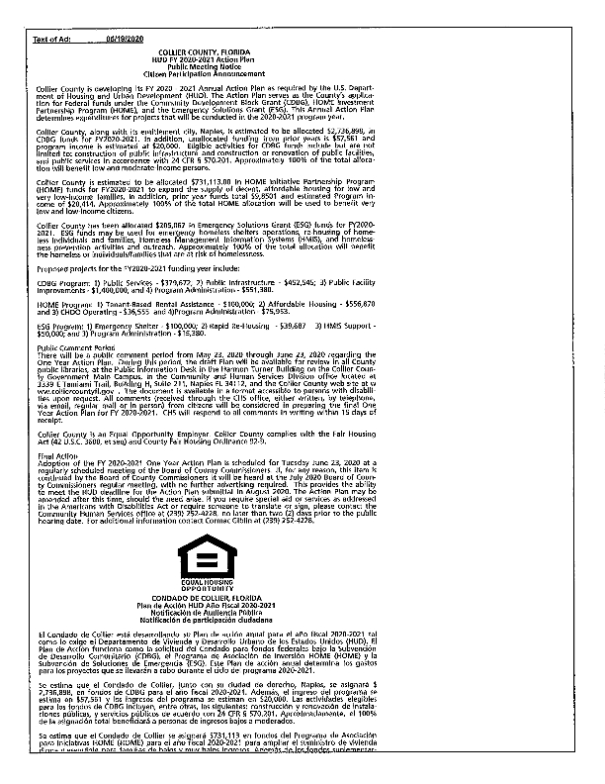
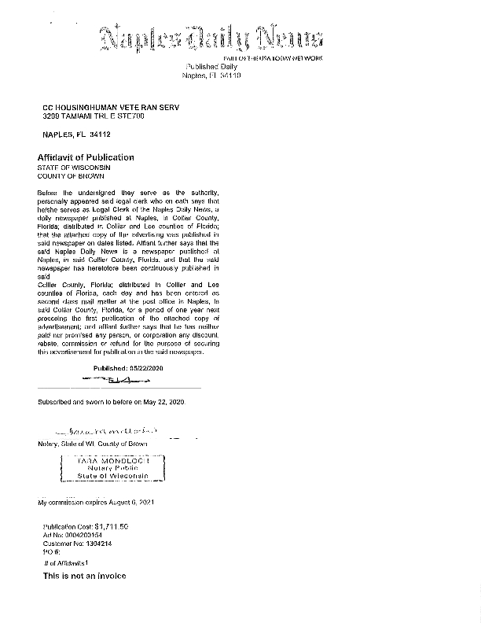
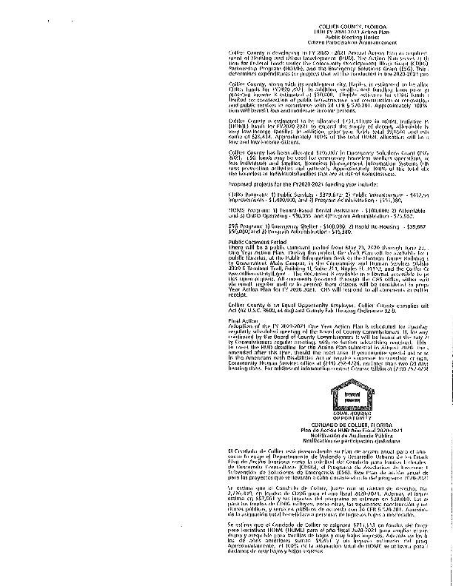
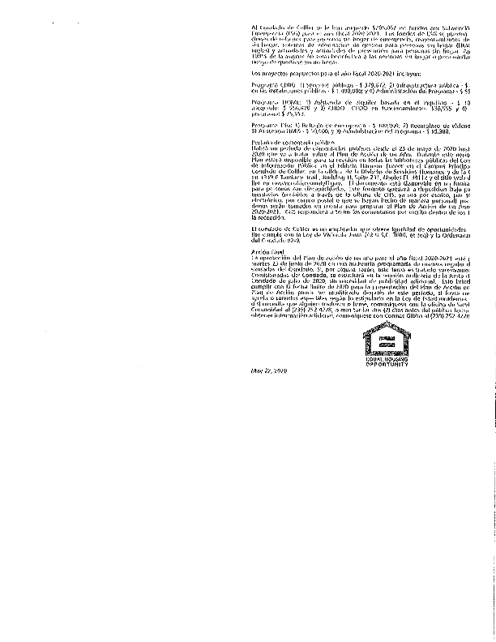
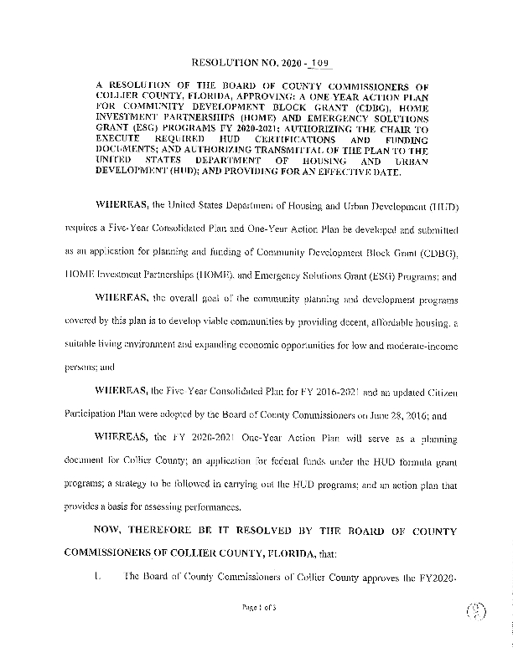
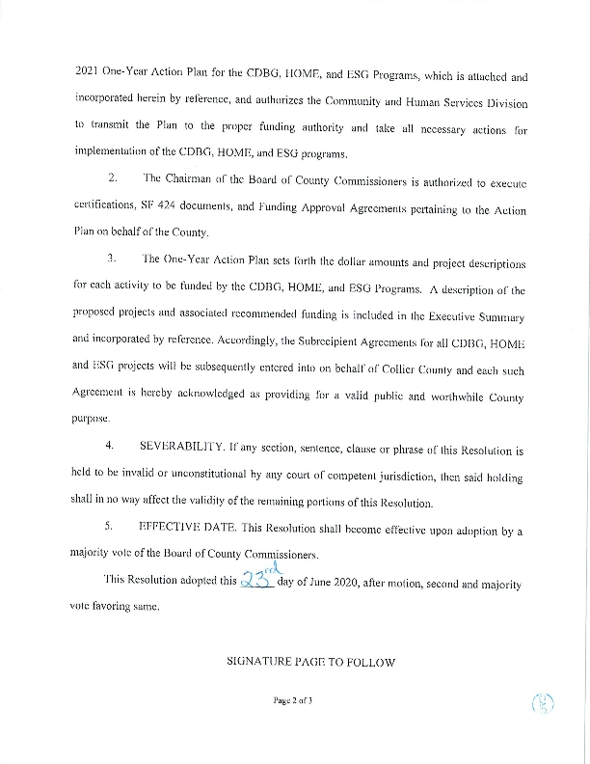
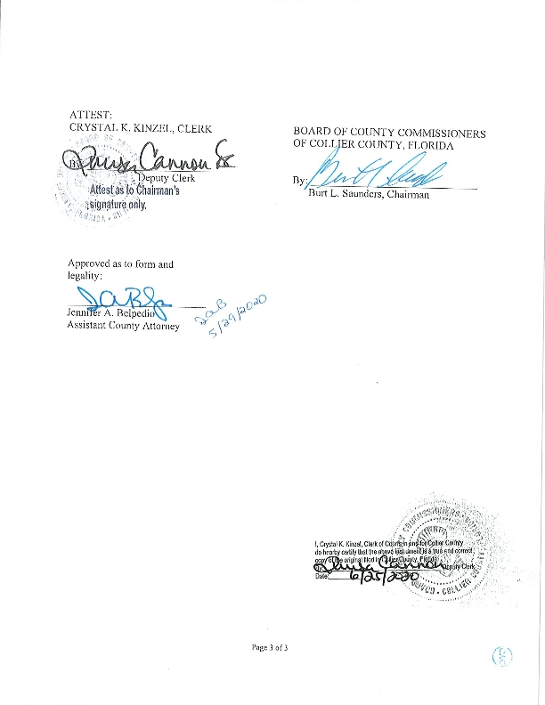

Grantee Unique Appendices
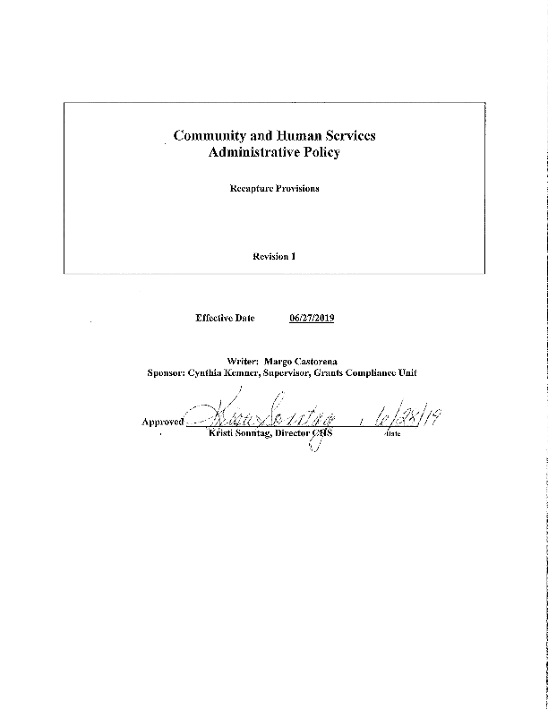
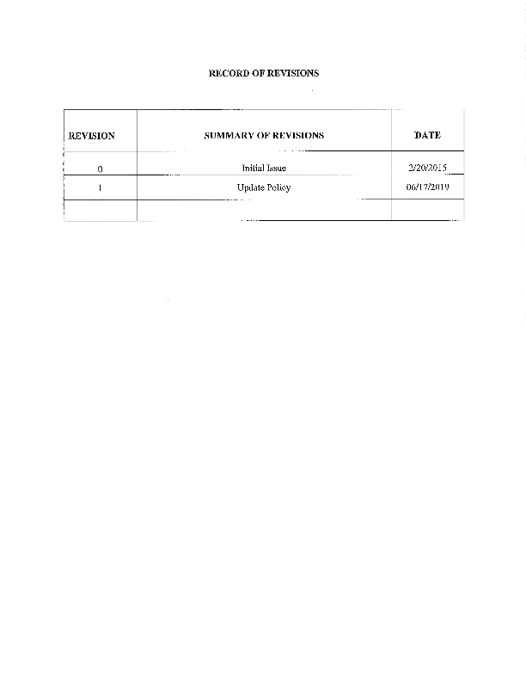
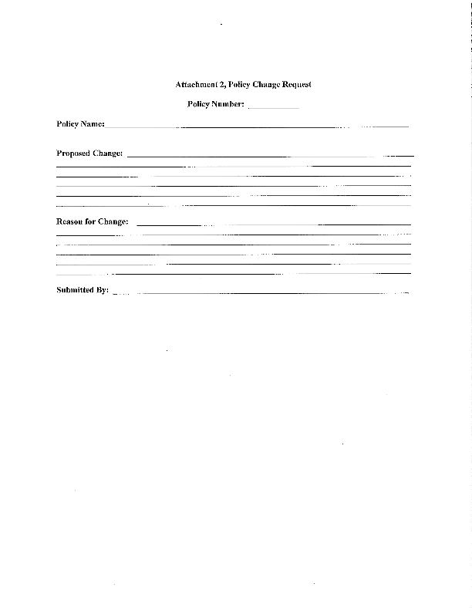
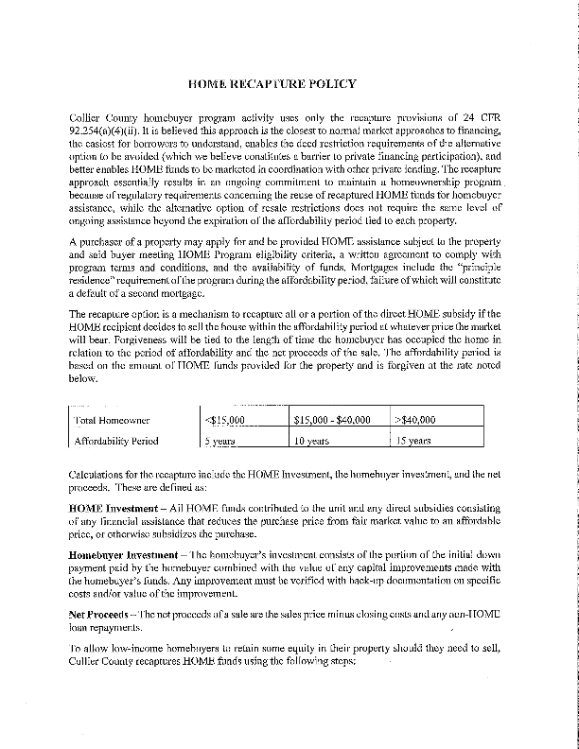
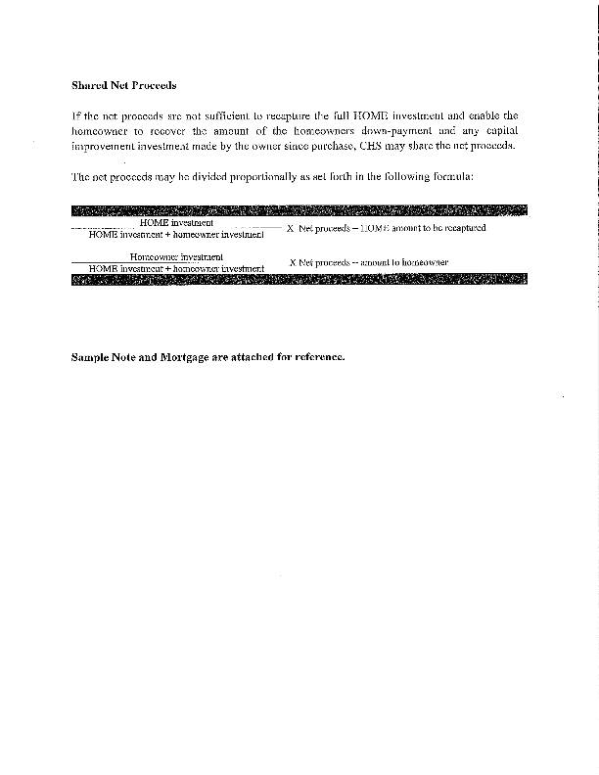
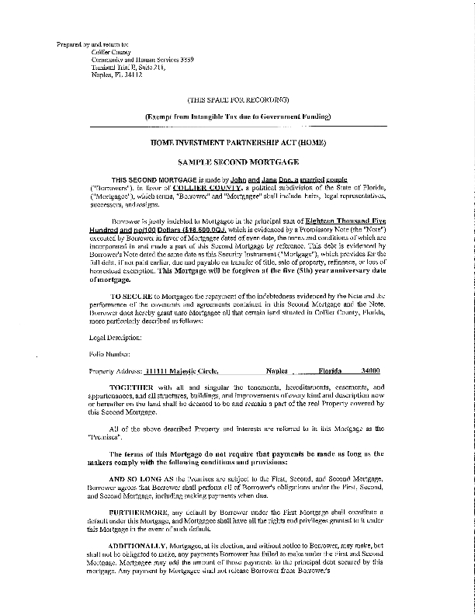
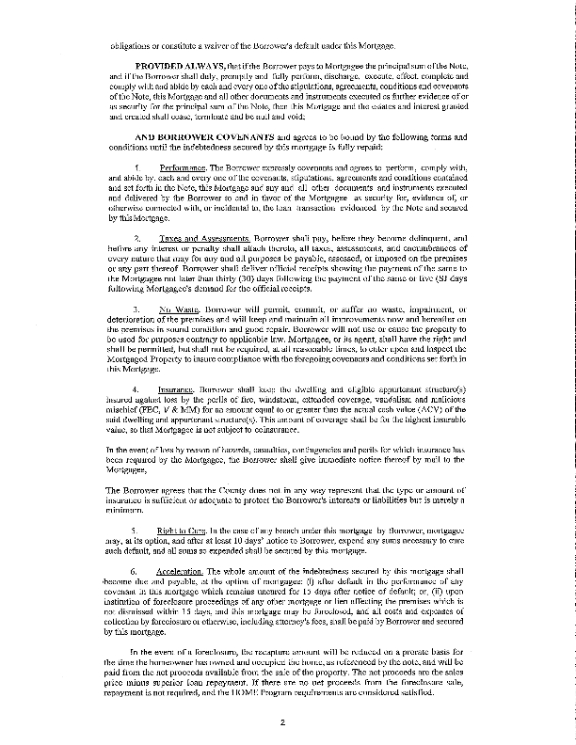
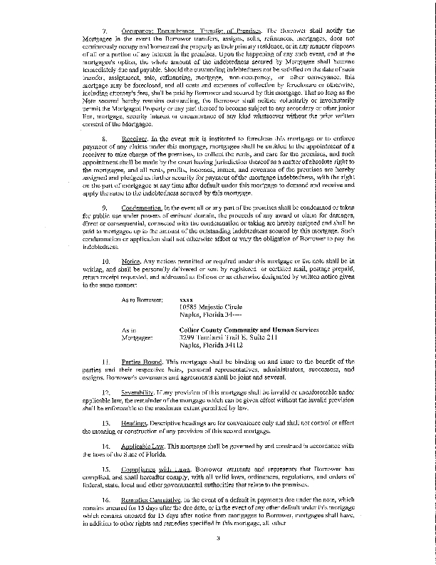
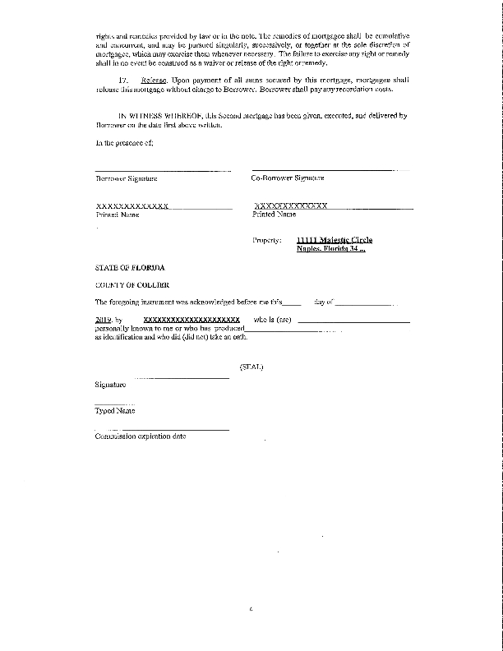
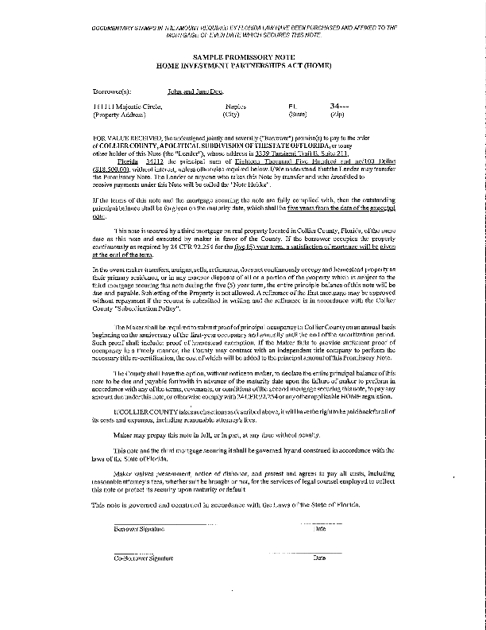
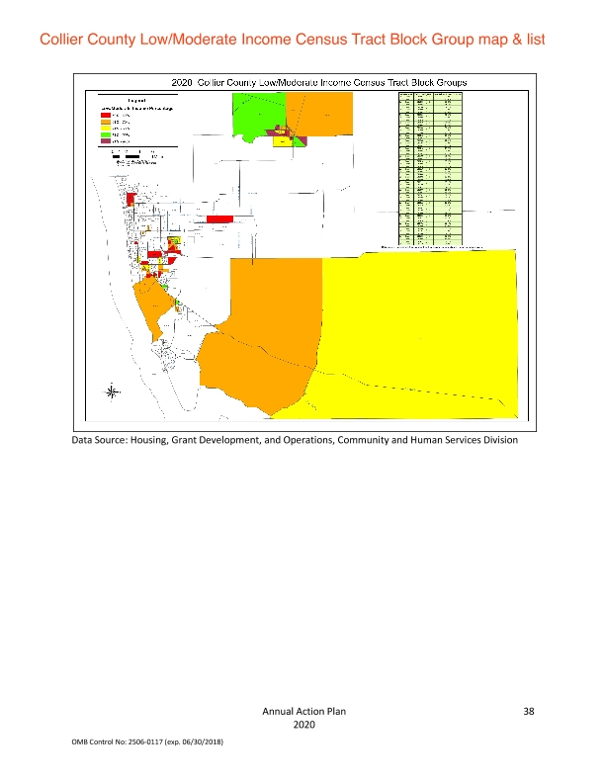
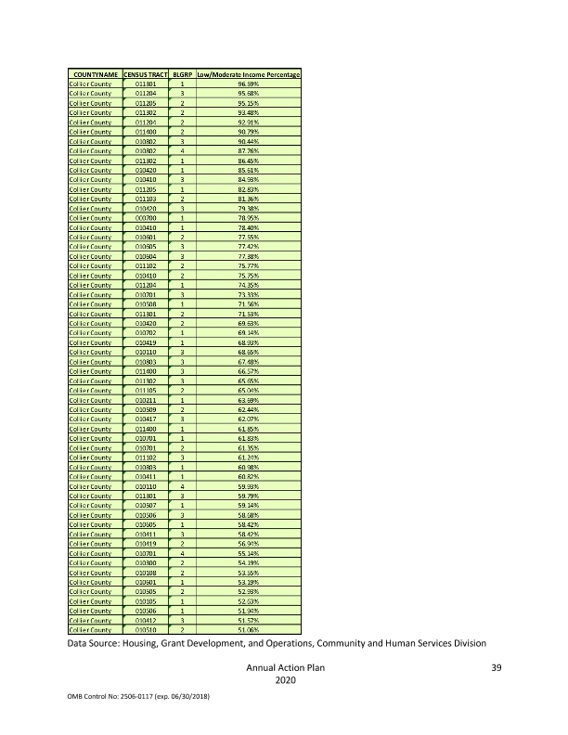

Grantee SF-424's and Certification(s)
